**3)c)**

h=zeros(1,1000);

h(1)=1;

h(2)=-0.5;

h(3)=0.75;

for i=4:1:1000

h(i)=h(i-1)/2;

end

[H,w] = freqz(h,1,1000,'whole');

plot(w,abs(H));

figure;

plot(w,angle(H));

**Magnitude Response:**

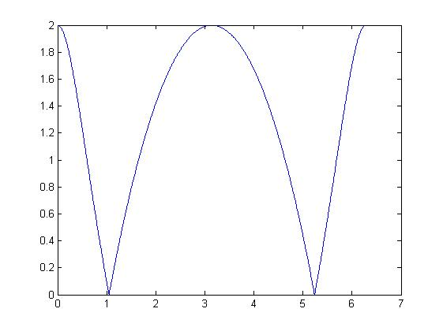

**Phase Response:**

